    Roll No | 1345
Name | Shubham Sarang
Topic | DLL
Title of Program | Doubly linked list

CODE:
/*
Name: Shubham Sarang
Roll no: 1345
Program: Doubly Linked List
*/
#include<iostream>
#include<conio.h>
using namespace std;
//Node template
class DNode
{
public:
int data;
DNode *left;
DNode *right;
};
class DList
{
DNode *head;
DNode *tail;
public:
DList()
{
head = NULL;
tail = NULL;
}
void Insert(int x);
void Display();
void Length();
void Search(int x);
void Remove(int x);
};
//List template
void DList :: Insert(int x)
{
DNode *t = new DNode();
t->data = x;
t->left = NULL;
t->right = NULL;
if(head == NULL)
{
head = t;
tail = t;
}
else
{
tail->right = t;
t->left = tail;
tail = t;
}
}

void DList :: Display()
{
if(head == NULL)
{
cout<<"Empty list";
return;
}

DNode *tmp = head;
cout<<"Forward Direction: ";
while( tmp!= NULL)
{
cout<<tmp->data<<"<->";
tmp = tmp->right;
}
cout<<"End of list"<<endl;
tmp = tail;
cout<<"Reverse Direction: ";
while( tmp!= NULL)
{
cout<<tmp->data<<"<->";
tmp = tmp->left;
}
cout<<"Start of list"<<endl;
}

void DList::Length()
{
int count=0;
if(head == NULL)
{
cout<<"Empty list";
return;
}

DNode *tmp = head;
while( tmp!= NULL)
{
count++;
tmp = tmp->right;
}
cout<<"Length of list: "<<count;
}

void DList::Search(int x)
{
if(head == NULL)
{
cout<<"Empty list";
return;
}
int flag = 0;
DNode *tmp = head;
while(tmp!=NULL)
{
if(tmp->data==x)
{
flag=1;
break;
}
tmp=tmp->right;
}

if(flag==1)
{
cout<<"Element "<<x<<" found";
}
else
{
cout<<"Element "<<x<<" not found";
}
}

void DList::Remove(int x)
{
if(head == NULL)
{
cout<<"Empty list";
return;
}
DNode *tmp = head;
DNode *prev = NULL;
int flag = 0;
while(tmp!=NULL)
{
if(tmp->data == x)
{
flag = 1;
break;
}
prev = tmp;
tmp = tmp->right;
}
//step 3: unsuccessfull search return control
if(flag==0)
{
cout<<"Element "<<x<<" not found ";
return;
}

//Step 4: Successful search, a single node deletion
if(head == tail)
{
head = NULL;
tail = NULL;
}
else if(tmp==head) //step 4 b: head node deletion
{
head = tmp->right;
head->left = NULL;
}
else if(tmp == tail) //step4 c: tail node deletion
{
tail = prev;
tail->right = NULL;
}
else //Step 4 d: any node in the middle
{
prev->right = tmp->right;
(tmp->right)->left = prev;
}
//Step 5: delete the node containing x
delete tmp;
cout<<"Element deleted ";
}
//Functions

//Menu

int main()
{
int ch, x, y,z, num;
DList d;
while(1)
{
system("cls");
cout<<"**Doubly linked list**"<<endl;
cout<<"1. Insert in DLL\n";
cout<<"2. Display List\n";
cout<<"3. Length of DLL\n";
cout<<"4. Search for the node in DLL\n";
cout<<"5. Remove a node\n";
cout<<"6. Exit\n\n";

cout<<"Enter your choice: ";
cin>>ch;

switch(ch)
{
case 1:
cout<<"Enter the data: ";
cin>>num;
d.Insert(num);
getch();
break;
case 2:
cout<<"The list is: ";
d.Display();
getch();
break;
case 3:
cout<<"Length of the list is: ";
d.Length();
getch();
break;
case 4:
cout<<"Enter the element to be searched: ";
cin>>y;
d.Search(y);
getch();
break;
case 5:
cout<<"Enter the element to be removed: ";
cin>>z;
d.Remove(z);
d.Display();
getch();
break;
case 6:
exit(1);
default:
cout<<"Incorrect option";
getch();
break;
}//end of switch
}//end while
}//end main
Enter element in list:
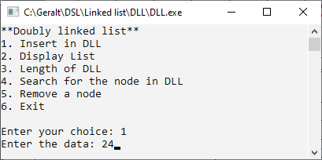
Display list:
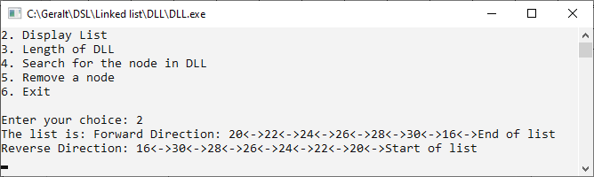
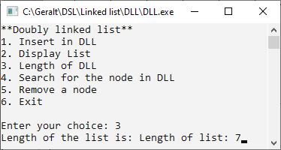
Length of list:
Search element:
Element found:
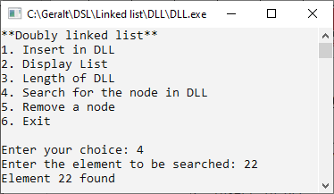
Element not found:
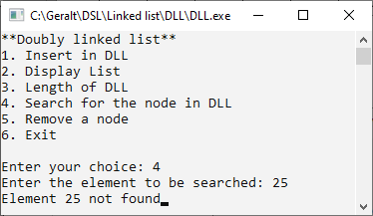

Delete element:
Head node deletion:
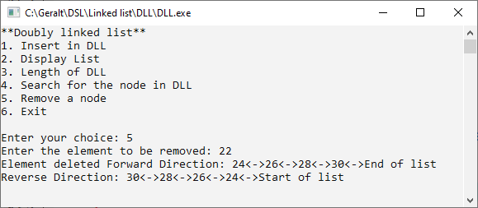
Tail node deletion:
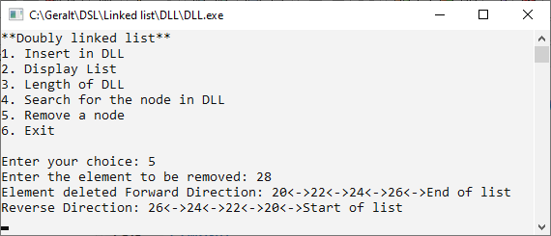
Mid node deletion:

